**ANNUAL REPORT**

**CEIRIOG UCHAF COMMUNITY COUNCIL**

**2023-2024**

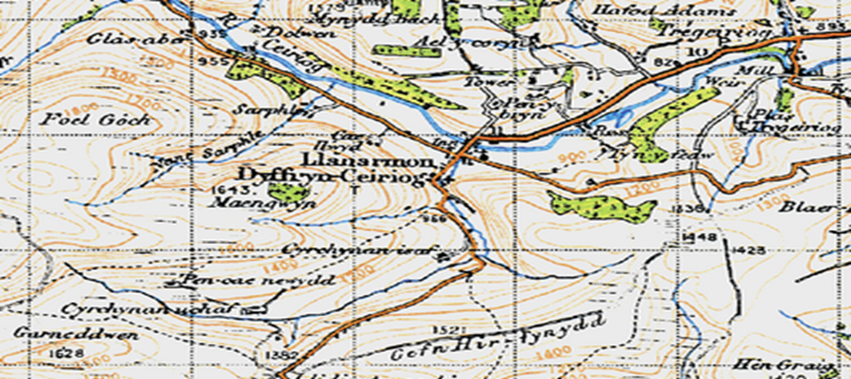

**1 OUR ROLE in 2023-2024**

**To act as a voice for our local area**.

**To express the views of the community to local authorities and to act when in the interests of our community.**

**To represent our community.**

**To be partners, but not part of, wider local government.**

**Community Councils must represent all people in the area without prejudice.**

**We aim to be non-sectarian and inclusive.**

**2 THE COMMUNITY COUNCIL 2023-2024**

Ceiriog Uchaf Community Council is the smallest Community Council in the Ceiriog Valley and the third smallest in the Wrexham County Borough. It represents two wards comprising of 160 homes from which our finances are derived - the ‘Precept’.

|  |  |
| --- | --- |
| **Llanarmon Ward** | |
| Cllr Dave Berriman | davetremyglog@gmail.com |
| Cllr Shimara Berriman | 01691 600974: shimaraberriman@gmail.com |
| Cllr Jane Claybrook | 07811 316 117: janeclaybrook70@hotmail.co.uk |
| Cllr Freja  Evans Swogger (Vice-Chair) | 07989 022486: frejafjes@gmail.com |
| **Llangadwaldr Ward** | |
| Cllr Keith L Benning (Chair) | 07980 013577: klb60@btinternet.com |
| Cllr Aled Jones | 01691 600890:  Tregeiriog |
| Cllr Glyn M Jones | 01691-600656 : Glanarfon, Tregeiriog |
| Cllr Eryl W Morris | 01691 600241: Ty Du, Tregeiriog |

During the past year we have had one vacancy following a resignation and in May 2023 following a contested election, we were pleased to announce that Aled Jones of Tregeiriog was appointed Councillor for the Llangadwaldr Ward

The Council continues to meet monthly, the first Tuesday of each month for 2 hours. All meetings are public in the Village Hall. Under recent legislation, there are few restrictions as to venue.

It considers a range of issues that directly affect the two Wards. As a Council we consider a range of community needs and concerns such as our roads, public spaces and our general environment. We examine all local planning applications and debate suggestions for improving our local community.

County Councillor **Trevor Bates** is a regular attendee and is our link into Wrexham CBC. Trevor can be contacted on **Trevor.bates@wrexham.gov.uk**

The Council has a limited power to make grants; 10% of last year’s income was donated to support local activities.

**4 PROPERTY AND PLACES**

**MOBILE COVERAGE AND THE ‘K6’ .** After years of campaigning by the Council, the Government has extended the mobile coverage to the Upper Valley in 2023 – for EE customers initially. BT hasrepaired and re-painted the K6 telephone box.

**VILLAGES OF BEAUTY**. Our continued thanks to Rosie and Rob Davies who do so much work to maintain the village centre with flower and plants. Also to Cllr Jane Claybrook and others who has gone to further areas in the Wards. We have announced the provision of a small grants scheme to support our environmental policy.

**GRAVEYARD AND CEMETERY**: These areas have been the focus of much attention and the Council’s thanks is extended to **St Garmon’s PCC** for their partnership. We are looking into the finances and feasibility of clarifying the on-going problems of ownership and we will be holding a public meeting later in the year.

**THE ‘DROP-IN’** Thanks to **Cllr Claybrook** and **Lorna Mills** and many volunteers who started a weekly warm-hub last winter attracting a regular number of people. This has been so successful that it will continue into the Spring and Summer as a weekly ‘Drop-In’.

**3 THE PEOPLE**

**COMMUNITY AGENT:** In September 2023we were very pleased to announce the extension of **Christina Brewin’s** role as ‘Community Agent’ to the villages. Christina brings much experience and 400 extra hours a year of support and help into the Upper Valley. We are very grateful to colleague Councillors in Glyn Ceiriog in their support for this extension of contract.

**CENTENARY OF THE ‘SAVING OF THE VALLEY’.** A huge thank you to **Sylvia** **and Trefor Jones** and many, many others for the organisation of 7 events through the year to mark the non-flooding of the Valley. So many wonderful stories from the events – so many, absolutely magical moments of celebration. The Council was proud to be a financial sponsor.

**NORTH WALES POLICE**: Our thanks to **Martin and Gareth** our local PCSOs for their on-going commitment to the area and attendance at Council. In the past year their roles have changed and we have less access to them for operational reasons. They are regulars to the Community Drop-In on a Friday allowing residents access.

**6 PAPERWORK**

**Web-Site:** Please stay in touch with the Council through this means. We try to get out paper versions of decisions and meetings but the ‘WWW’ will give quicker access.www.ceirioguchaf.co.uk. It has limitations in terms of photographs but provides up to date news of the Council’s activities and wider news from the two Wards. Also find us on Facebook

**Glyn News:** The Editor **Frank Griffiths** is tireless in keeping this vital communication going along the Valley and our Council has a regular news slot each month.

**Council Governance:** As a responsible and well-managed Council we have a range of policies and this year we approved new Standing Orders and a Code of Conduct for behaviour.

**5 PARTNERS in 2023-2024**

Effective councils operate in partnership with other organisations and we are very pleased to have been linked to the following this year:

**Glyn Ceiriog Community Council** (working jointly to bring the Community Agent into the Upper Valley. **Ysgol Llanarmon, Memorial Institute** forevents linked to the Centenary. **St Garmon’s PCC** inhelping us to plan for the ownership of the graveyard and cemetery.  **The Centenary Hall Committee** in allowing events to take place, especially the Community Drop-In .

**7 FINANCES**

**£** The annual precept is £10,000 – equal to £59 per Band D household per year. We notified our intention to raise this from last year’s £6,000 because we need to plan for the potential ownership of the cemetery and graveyard.

**£** Accounts are audited by **Brian Pratt** and were submitted for the year to the 31/03/2023 and we have received qualified approval by Audit Wales.

**£** Provisional accounts up to 31/03/2024 which are subject to audit, are now available and attached.